# File permissions in Linux

## Project description

In this project, I am checking the permissions of files and directories to confirm that the proper users and groups are authorized to their respective files and directories. Having correct permissions keeps the system secure. Permissions will be checked and changed based on the needs of the research team. I will be doing this via the bash shell.

## Check file and directory details

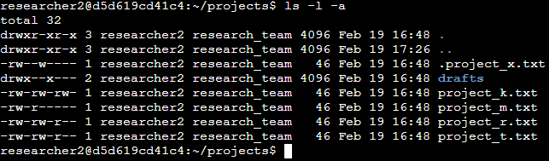

## Describe the permissions string

The permission strings shown above are the read, write, and executable permissions for these project files. Starting at the left of the permission string the d represents the directory permission. After that the permissions come in sets of threes for the user, group, and other. The r stands for read, the w stands for write, and the x stands for executable. Read allows the user to view the file, write allows the user to edit the file, and executable allows the user to run the file.

## Change file permissions

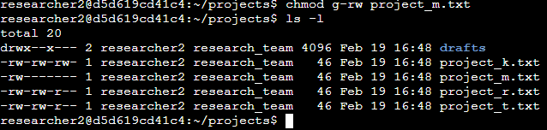

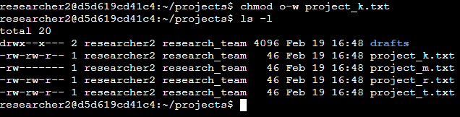

In the first screenshot, the chmod g-rw command was used on the project_m.txt files to change the read and write permissions for the group; research_team.   
  
The second screenshot shows that the chmod o-w command was used to change the write permissions for the project_k.txt file for the other group.

## Change file permissions on a hidden file

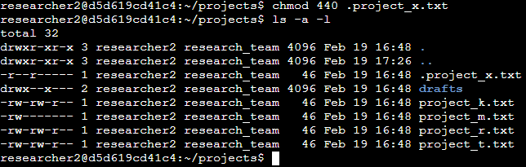

The screenshot above shows changing multiple permissions for the hidden file .project_x.txt. The command chmod 440 was used as a quick way to change multiple permissions at once. The first 4 in the sting refers to the user permissions and gives the read permission. The second 4 refers to the group permissions and also gives the read permission.   
The 0 refers to the other and does not grant any permissions to anyone outside of the user or group.

## Change directory permissions

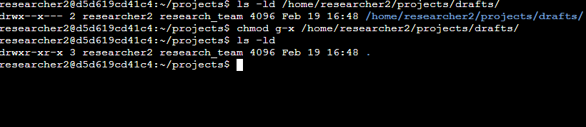

This screenshot shows changing the permissions for the directory where the project files are held. The command chmod g-x /home/researcher2/projects/drafts/ changed the permissions for for the drafts subdirectory so that the user researcher2 could execute it.

## Summary

This project explained what permissions are and how they work in a simple directory and file system in Linux. Permissions were granted and taken away for public and hidden files. The directory permissions were also changed to show how to secure them from users that do not have permissions to access them.